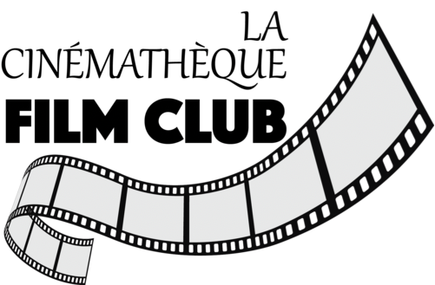

Fall series 2022
The Passion Of Joan Of Arc
(1928)
Directed by Carl Dryer

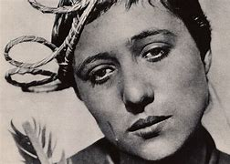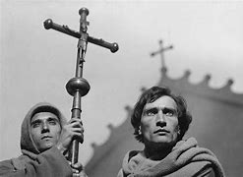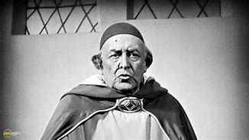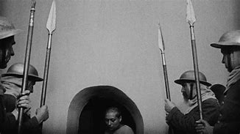

Carl Theodor Dreyer 1889-1968
Dreyer was born illegitimate in Copenhagen, Denmark. His birth mother was an unmarried Scanian maid named Josefine Bernhardine Nilsson, and he was put up for adoption by his birth father, Jens Christian Torp, a married Danish farmer living in Sweden who was his mother's employer. He spent the first two years of his life in orphanages until his adoption by a typographer named Carl Theodor Dreyer, and his wife, Inger Marie (née Olsen). He was named after his adoptive father, but in accordance with Danish practice, there is no "Senior" or "Junior" added to their names to distinguish them from each other.
His adoptive parents were emotionally distant and his childhood was largely unhappy. He later recalled that his parents "constantly let me know that I should be grateful for the food I was given and that I strictly had no claim on anything, since my mother got out of paying by lying down to die." But he was a highly intelligent school student, who left home and formal education at the age of sixteen. He dissociated himself from his adoptive family, but their teachings were to influence the themes of many of his films.
Dreyer was ideologically conservative. According to David Bordwell, "As a youth he belonged to the Social Liberal party, a conservative group radical only in their opposition to military expenditures."[Dreyer recalled, "Even when I was with Ekstrabladet, I was conservative ... I don't believe in revolutions. They have, as a rule, the tedious quality of pulling development back. I believe more in evolution, in the small advances."
Dreyer died of pneumonia in Copenhagen at age 79. The documentary Carl Th. Dreyer: My Metier contains reminiscences from those who knew him.

Career
As a young man, Dreyer worked as a journalist, but he eventually joined the film industry as a writer of title cards for silent films and subsequently of screenplays. He was initially hired by Nordisk Film in 1913.
His first attempts at film direction had limited success, and he left Denmark to work in the French film industry. While living in France he met Jean Cocteau, Jean Hugo, and other members of the French artistic scene. In 1928 he made his first classic film, The Passion of Joan of Arc. Working from the transcripts of Joan's trial, he created a masterpiece of emotion that drew equally on realism and expressionism.
Dreyer used private finance from Baron Nicolas de Gunzburg to make his next film as the Danish film industry was in financial ruin. Vampyr (1932) is a surreal meditation on fear. Logic gave way to mood and atmosphere in this story of a man protecting two sisters from a vampire. The movie contains many indelible images, such as the hero, played by de Gunzburg (under the screen name Julian West), dreaming of his own burial and the animal blood lust on the face of one of the sisters as she suffers under the vampire's spell. The film was shot mostly silent but with sparse, cryptic dialogue in three separate versions – English, French, and German.
Both films were box office failures, and Dreyer did not make another movie until 1943. Denmark was by now under Nazi occupation, and his Day of Wrath had as its theme the paranoia surrounding witch hunts in the seventeenth century in a strongly theocratic culture. With this work, Dreyer established the style that would mark his sound films: careful compositions, stark monochrome cinematography, and very long takes.
Dreyer made two documentaries in the more than a decade before his next full-length feature film, in 1955, Ordet (The Word), based on the play of the same name by Kaj Munk. The film combines a love story with a conflict of faith. Dreyer's last film was 1964's Gertrud. Although seen by some as a lesser film than its predecessors, it is a fitting close to Dreyer's career, as it deals with a woman who, through the tribulations of her life, never expresses regret for her choices. Dreyer said of it: "What I seek in my films, what I want to obtain, is a penetration to my actors' profound thoughts by means of their most subtle expressions. For these are the expressions...that lie in the depths of his soul. That is what interests me above all, not the technique of the cinema. Gertrud is a film that I made with all my heart." David Thomson, in his The New Biographical Dictionary of Film, says it "awaits rediscovery as Dreyer's finest film and vindication of his method."
The great, never finished project of Dreyer's career was a film about Jesus. Though a manuscript was written (published in 1968) the unstable economic conditions and Dreyer's own demands of realism together with his switching engage one of the masterworks of the silent era, Carl Theodor Dreyer’s The Passion of Joan of Arc (1928) harrowingly envisions the saint’s trial and execution, evoking her physical and spiritual torment through an iconically expressive performance by Reneé Falconetti. With intimate close-ups, oblique camera angles, and stylized lighting, Dreyer makes palpable the sheer immediacy of Joan’s struggle in captivity and under threat of death. This intensity is well complemented by Richard Einhorn’s 1994 oratorio Voices of Light, a stirring piece of music that was inspired by The Passion—which, like most silent films, lacks an official score—and has often accompanied it over the past quarter century. In addition to giving viewers the option of watching the movie along with Voices of Light, our packed new edition of the film includes an interview with Einhorn about the scoring process. In the above clip from the supplement, the composer discusses the substantial amount of research that went into the piece, including his reading of medieval texts in conceiving the libretto and his pilgrimage to France, where he recorded the bells at the church where Joan prayed long ago, a sound he later wove into his orchestral and vocal work.

Perhaps no face has been scorched into cinema quite like Renée Falconetti’s, whose portrayal of Joan of Arc is considered to be the face of tension-filled injustice and martyrdom put to film. 1928’s “The Passion of Joan of Arc” is Carl Theodor Dreyer’s spiritual nightmare, a classic work of silent film that singed Joan of Arc’s tragedy to screen and does so masterfully in starkly haunting and poetic black and white. Declared a heretic by her end, the film follows the trial of Joan of Arc, a recently captured teenager who felt compelled, through what she interpreted as divine calling, to lead the French into battle with England during the Hundred Year War
Joan (Falconetti) in film form is mostly portrayed as the purest of beings, primarily a translucent, innocent face bursting with tears, emotion, recoil, and confusion by her investigation and damnation by man. Using close-ups of her expressive face not only guides our emotions but also our understanding of Joan beyond historical recollection along with her mental wellbeing throughout. Dreyer stated that he intended the film to focus primarily on the confrontational faces of the cast as to ascribe a specific spirit of the time and to mitigate the viewer’s contextual and emotional understanding of the story. While the film uses sets, beautifully spacious ones at that, but it relies heavily on character’s faces to relay the intense feelings and sensations. While not modern, it is a significantly performance-heavy film that transcends time and place.
Joan has no hidden motivations; she is displayed as simply a peasant French girl who honestly believed she was called upon by God to vanquish England from France. She is a true believer. Dreyer’s description of Joan is that of “the virgin of Orleans”, and no makeup was used to strive for that untouched virtue and humanity. Joan is punished for not only her steadfast beliefs but for her brave venture into the Hundred Years War and most prominently, embarrassing the British. Joan was also targeted for wearing men’s clothing (as it is forbidden in the Old Testament), and signed an agreement stating she did not actually receive divine guidance and that she would stop (Joan herself could not read or write) wearing men’s clothing. Joan later that day was denied women’s clothing, thus having her break the agreement she had previously made and was found guilty. The first, small amount relief is quickly withdrawn as they condemn the already overwhelmed Joan. She is successfully tried for heresy and witchcraft, and undeservedly found guilty and burned at the stake. The unembellished, brutal ending of Joan crying out to Jesus, as she is burned alive is the perfect ending sentiment to this madness of persecution.
Researchers now surmise that Joan might have suffered from disorders ranging from epilepsy to schizophrenia, making the story somewhat more tragic that Joan probably just entirely misunderstood and suffered from delusions through no fault of her own. Joan would often state that she loved the sound of bells, as that was when she would hear the voices of God or spirits. One of the film’s composers, Richard Einhorn, even recorded the bells from Joan’s own church in France and used them variously during specific scenes to recall her spirituality and calls from God.
It took the Catholic Church almost 500 years to officially recognize Joan as a saint, even though it thoroughly and systematically refuted her trial 25 years following her death. Her unbroken faith is in part admirable and disturbing as it led to her rise and subsequent downfall, but her spirit is communicable and touching despite what the troubling realities behind it. Arguably the film advanced human compassion and understanding, as this was the first glimpse for many into a real hypocrisy that was impossible to ignore or disregard. It is a captivating story that has since become a uniquely feminist one. “The Passion of Joan of Arc” acts like a documentation of that incident (it was taken mostly directly from the court documents that are still present) and a fitting tribute to the final moments of a remarkable life.
“The Passion of Joan of Arc” gets a Blu-Ray upgrade from the Criterion Collection. The original 2-disc set from 1999 has been downsized to a single Blu-Ray, along with the special features that were present on that release. The upgrade to a 2K digital restoration has been a long time coming and with the added features of this remarkable work, seemingly worth the wait. The film has two versions, one at 24 frames per second, and another at 20 frames per second with the original Danish intertitles. The 24 frame version is a bit fast but otherworldly, but I would argue the preferred method. There is a version history included to guide you through the differences and how the film was originally viewed. There are three scores for the film included since the film is silent, I would recommend giving one a try at the very least. The classic Richard Einhorn’s “Voices of Light” version, one by Goldfrapp’s Will Gregory and Portishead’s Adrian Utley, and one composed by pianist Mie Yanashita. I was not too accustomed to any particular selection and found all three to be worthy of inclusion and interesting enough in their efforts. Casper Typjerg, a Danish film scholar provides an excellent audio commentary on the film’s history along with Joan’s. New supplemental material includes a new interview with Einhorn, a conversation between Gregory and Utley, updated subtitle translations, and a video essay by Typjerg exploring the film’s debate over the frame rate. In the booklet is an essay by film critic Mark Le Fanu, Dreyer’s own statement from 1929, along with the full libretto for “Voices of Light” is included. Also included is the trailer, the production design archive, an interview with actor Falconetti’s daughter and biographer from 1995. A film of this stature and history gets a well-deserved proclamation.

The Passion of Joan of Arc (1928)
Carl Theodor Dreyer | ... | (as Carl Th. Dreyer)

Writing Credits (in alphabetical order)
Joseph Delteil | ... | (writer)
Carl Theodor Dreyer | ... | (writer)

Cast (in credits order) verified as complete
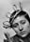 | Maria Falconetti | ... | Jeanne d'Arc (as Melle Falconetti)
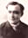 | Eugene Silvain | ... | Évêque Pierre Cauchon (Bishop Pierre Cauchon) (as Eugène Silvain)
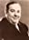 | André Berley | ... | Jean d'Estivet
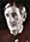 | Maurice Schutz | ... | Nicolas Loyseleur
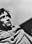 | Antonin Artaud | ... | Jean Massieu
 | Michel Simon | ... | Jean Lemaître
 | Jean d'Yd | ... | Guillaume Evrard
 | Louis Ravet | ... | Jean Beaupère (as Ravet)
 | Armand Lurville | ... | Juge (Judge) (as André Lurville)
 | Jacques Arnna | ... | Juge (Judge)
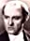 | Alexandre Mihalesco | ... | Juge (Judge)
 | Léon Larive | ... | Juge (Judge)

