Springfield Library film series
Something In the Air
(1973)
Directed by Olivier Assayas

The French title of "Something in the Air," Olivier Assayas' semi-autobiographical coming of age film, is "Apres mai," which translates into English as "After May." And everyone, or at least everyone of a certain age, knows that "May" means one thing in French: May 1968. "Bliss was it in that dawn to be alive," wrote Wordsworth of an earlier revolution in France, "But to be young was very heaven!"
If that isn't an actual on-screen epigraph in Assayas' movie, it's an implicit one. "Something in the Air" is suffused with its auteur's nostalgia for a galvanizing moment in his adolescence that coincided with a tumultuous and transformative period in modern French history: student protests, demonstrations, riots, police brutality, workers occupying factories, students occupying universities, culminating in a general strike that shut down the nation's economy and government. Those were the days!
Nostalgia, of course, is associated with a longing for lost innocence, an ache for that quintessentially youthful optimism that views the world as open to endless possibility. The movie is populated with fresh-faced would-be high school revolutionaries whose precociousness is mingled with a comically endearing naïveté. These kids are poised on the cusp of "real life," facing a dizzying array of new experiences they want to try out. While earnest and serious, they're not sullen -- though they hardly ever laugh, which is mildly disconcerting in such fresh-faced youngsters.
With so many issues of life-and-death importance swirling around them, nobody has time to waste on polite chit-chat about trivialities like the stock market or sports teams. Conversations, seething and roiling with passion and conviction, invariably turn into fervent debates about the only things that matter: politics, art, philosophy, sex, love and friendship. Those subjects are the very molecules of the air these kids breathe, the wine they drink, the nourishment that feeds their developing bodies and minds. From the perspective of 2013, it all seems somewhat quaint — foolhardy but also rather noble.
What story there is in "Something in the Air" follows would-be painter and filmmaker Gilles (Clément Métayer) as he wanders impulsively after romance, adventure, artistic ambitions and revolutionary politics, from the suburbs of Paris to Italy and back again, during the summer of 1971. The first time we see him he's carving an anarchy symbol into his wooden school desk with the sharp end of a compass. Right away we know he's an artist of sorts, whose interests extend to graffiti, propaganda posters, political leaflets and personal watercolors he allows few people to see.

Assayas looks back on the values and priorities of the time with a vision that's both wry and tender. When Gilles asks a member of a radical collective if he can borrow their 16mm camera to make a short film, he's told: "We do agit-prop. Usually, we don't lend for fiction." It's a line that crystallizes the tension between aesthetics and politics underlying almost every interaction.
In Florence, Gilles and a girlfriend come upon an outdoor screening of a documentary about Laos produced by "the Hedgehog collective." The post-screening Q&A is priceless, as the usual self-congratulatory audience remarks are upstaged by challenges to the filmmakers' ideological purity.
A viewer criticizes their film for adhering to the "classical style" of the bourgeoisie: "Shouldn't revolutionary cinema employ revolutionary syntax?" But, counters one of the filmmakers, "Such a style would be a shock to the proletariat. Our role is to enlighten them." And what if this so-called "revolutionary syntax" was actually a manifestation of the "individualistic style of the petit bourgeoisie"? After all, "style" itself is for esthetes: "You can't make entertainment in revolutionary times."
Gilles' verdict: "Boring films, primitive politics."
It's almost like having a critic providing a running commentary track from within the movie. Of course, Gilles is a stand-in for Assayas, who is a former film critic, so there's a wholeness to the movie's conception, a sense that his sensibility is shining through in every frame — though compared to the operatic fever-dream of Bernardo Bertolucci's daring, transgressive, NC-17-rated "The Dreamers" (2003), it's pretty tepid stuff. Still, it has its own undeniable, understated charm.
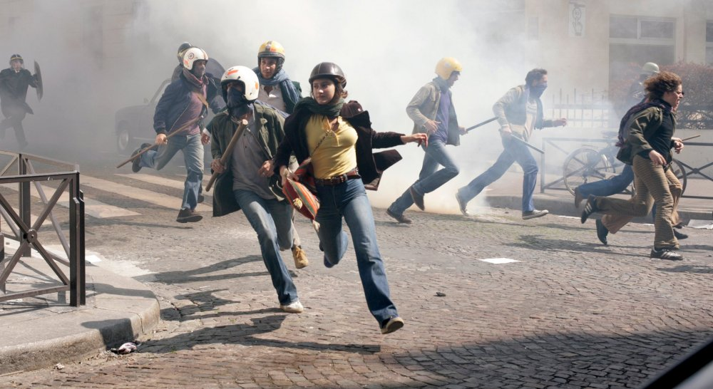
Since its completion, Olivier Assayas’s wistful Something in the Air has acquired additional layers of loss and regret. The film is dedicated to the director’s filmmaker friend, the late Laurent Perrin, while its editor Luc Barnier, a long-term Assayas associate, also died last year. The film’s final sequence is set to a number by British avant-rocker Kevin Ayers, who died this February
All this gives Something in the Air a surplus of nostalgic poignancy. Assayas’s reminiscence of the early 1970s (following his 2005 autobiographical text A Post-May Adolescence) might recall the last words of Sentimental Education, as Flaubert’s characters Frédéric and Deslauriers, remembering their youth in turbulent times, remark: “That was the best thing we ever had.”
In Flaubert’s novel, these words carry a bitter charge, as Frédéric has failed to understand the historical urgency of the times he’s sleepwalked through. By contrast, Assayas’s student hero (and counterpart) Gilles very consciously lives his epoch to the full, in all its complexity and contradiction. Something in the Air looks back to the early 70s as, if not a lost paradise, at least a lost hotbed of infinite possibilities, and if the film is nostalgic, this is a nostalgia well earned. Assayas depicts a culturally and politically vibrant era made and lived through by intelligent, sensitive beings taking full advantage of their moment.
There is nothing glibly distancing about Assayas’s treatment of the period – which comes as a shock, given the way that British and American films about this era almost routinely use caricature to defuse their embarrassment at bygone idealism and stylistic exuberance. It’s bracing to see how Assayas respects the genuine experimentalism of the time – treating, say, a spacy improv-rock concert with liquid light show not as a grisly efflorescence of baba-cool hippie-ism, but as a vivid and valid manifestation of arts-lab culture.
The film’s English title – with its nod to the 1969 Thunderclap Newman hit, not featured on the soundtrack – alludes to the mood of a certain time, to something new about to emerge. However, the original French title, Après mai (‘After May’), suggests a theme of aftermath, of a generation arriving on the scene just too late – the film depicts the younger siblings of the Class of 68, their political passion coming to the boil three years after France’s national ferment failed to bring about the hoped-for tabula rasa.

No less than their immediate elders, Assayas’s heroes are caught in the crossfire of ideological divisions. As we see early on, anyone standing up to make a point at a meeting runs the risk of being shouted down as a Trotskyite or worse, while older militants disapprove of the agitprop language of the younger radicals: one veteran activist tut-tuts at the schoolkids’ penchant for sexually provocative imagery. Nor would the radical old guard have had much time for the burgeoning cause of women’s liberation. It’s a lesson Gilles’s fellow radical Christine learns as she joins up with – and becomes dogsbody to – a group of macho cine-militants.
Assayas himself has noted in interviews that old-school French Marxists, committed to proletarian victory, regarded the artistic and moral transformations of the 60s as so much petit-bourgeois distraction, and the personal liberations offered by pop culture as counter-revolutionary if anything. Gilles is irresistibly drawn to pop and to a whole spectrum of artistic and poetic activity. The political movements that attract him do so as channels of self-expression: Assayas has said that he was himself drawn to vital but ephemeral sites of political activity, short-lived groups such as VLR (Vive la révolution) and the FLJ (Youth Liberation Front), to which Gilles belongs.
Ephemerality, intensity and sudden change are bound to be of the essence in serious films about youth, hence this film’s theme of combustibility. Early on, the young militants throw Molotov cocktails at school guards; later, one of them takes part in the burning of a car, in an obscure guerrilla operation. In the heat of emotion, Gilles burns one of his drawings; elsewhere, he reads a poem from Gregory Corso’s collection Gasoline, later burning that page.
And Gilles’s ex-girlfriend Laure is apparently killed in a fire at a stoned house party. This is a dazzling set piece, the camera wandering after Laure through house and garden, where a haystack is alight, up to the abrupt ending, flames bursting through a doorway as a Soft Machine track hits its climax. This mesmerising sequence, demonstrating Assayas’s characteristic fluency in coordinating camera and music, recalls a similarly fiery party in L’Eau froide, which Assayas made in 1994, aged 39, when he could still be considered a representative of ‘young French cinema’. To echo it now is to emphasise the sense of recollecting lost days.
Yet it is not a matter of looking back from a knowing position of age and wisdom. Assayas in no way presents these young people’s adventures as callow follies. If anything, he’s indulgent towards them. It’s easy to forget, for much of the film, that his heroes have unthinkingly been involved in actions resulting in a man’s injury – something for which, later, the victim isn’t ready to forgive them. In fact, the sole concern of Gilles and co has been to escape to Italy and forget the incident – which the film itself largely does in the meantime, focusing on their amorous idylls or discoveries of agitprop cinema and the Afghan hippie trail.
The repercussions of Gilles’s action constitute the only blind spot for a character who is otherwise strikingly lucid. “I live in my fantasies,” he anxiously admits. “When reality knocks, I don’t open.” Acutely self-conscious, Gilles envies the bohemian Laure, who lives day to day, while he admits, “I’m afraid to miss out on my youth.”
But for this nascent artist, it’s important to be creatively awake and active, rather than lose himself in the rush of either hedonism or history. It’s vitality itself that finally prevails (near the end, Gilles reads the Situationist dictum, “The demand for life has become a revolutionary programme”) and the film comes out strongly for the virtue of being true to yourself (or, in the more philosophically skewed French word, cohérent). A loose, episodic narrative provides a framework for a remarkably dense set of period references, taking in specific political groups and incidents, developments in contemporary art, post-psychedelic musical styles and various types of cinema – from agitprop documentary to the ludicrous lost-world romp that Gilles ends up working on at Pinewood.
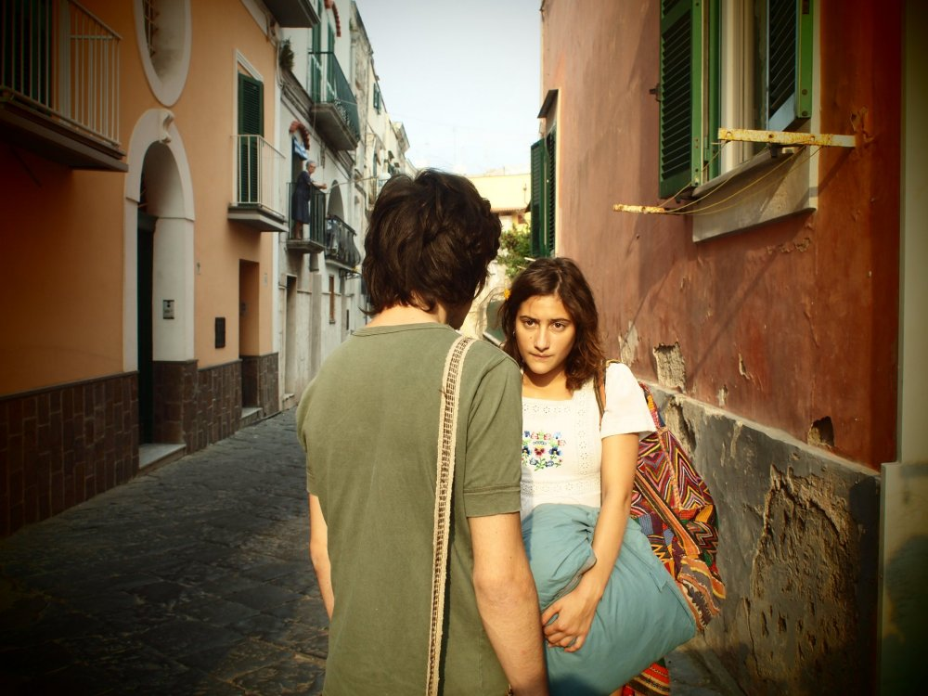
During the Italian trip, following the screening of a documentary about Laos, one viewer asks, “Shouldn’t revolutionary cinema use revolutionary syntax?” To which someone else retorts that revolutionary style is itself a petit-bourgeois conceit (a characteristic aesthetic-ideological catch-22 of the period). Assayas’s own style in this feature is neither revolutionary nor to be dismissed as petit-bourgeois art cinema. With its long takes, contemplative fades to black and langorously exalted crane moves, Something in the Air belongs to the lyrical-classical wing of Assayas’s oeuvre – Late August, Early September (1998) and Summer Hours (2008) – as opposed to the more confrontational or fractured forms of Demonlover (2002) and Carlos (2010).
The contradictions are still there to be argued over – some will wonder at Assayas making such a calm, reconciled film about such an angry epoch. But this film’s gentler style of fragmentation feels entirely appropriate to the business of recollection at a distance. And, in both visual and sonic terms, from the patterns of the tie-dye T-shirts to the whine of the prog-rock synths, Assayas has recreated the styles of the period in a way that, for once, isn’t distorted by retrospective irony, but is tenderly rather than reverently spot-on – in des images justes.

